PrakritiOPD – Panchakarma Management System

1. Introduction
PrakritiOPD – Panchakarma Management System is a relational database system designed to efficiently manage operations of a small Ayurvedic OPD clinic specializing in Panchakarma therapies. The system aims to digitize patient management, therapy planning, appointment scheduling, billing, payments, therapy sessions, and inventory tracking.
The objective is to create a scalable and normalized RDBMS that ensures data integrity, minimizes redundancy, and supports real-world operational workflows of a Panchakarma clinic.

2. Problem Statement
Traditional small Panchakarma clinics rely on manual record keeping for patient details, therapy schedules, billing, and payments. This leads to:
- Data redundancy
- Poor tracking of therapy sessions
- Billing errors
- Difficulty in managing therapy packages
- Lack of inventory monitoring
- No structured reporting system
PrakritiOPD solves these issues by implementing a structured relational database system with enforced integrity constraints and optimized querying capability.

3. Objectives
The system must-
- Maintain patient records securely
- Manage doctor and staff information
- Create structured treatment plans
- Track therapy sessions
- Handle appointment scheduling
- Generate bills and record payments
- Manage therapy packages
- Track inventory usage
- Ensure referential integrity and business rule enforcement
- Provide optimized reporting through SQL queries

4. Scope of the System
The system is designed specifically for:
- Small-scale Panchakarma OPD clinic
- Walk-in patients (no room admissions)
- Session-based therapy management
- Structured billing
- Basic inventory monitoring
Rightnow The system does not include-
- Multi-branch management
- IPD room allocation
- Insurance claim processing
- Online booking portals

5. Functional Requirements

A. Patient Management
- Register new patients
- Store demographic details
- Maintain medical diagnosis history
- Retrieve patient treatment history

B. Staff & Role Management
- Maintain unified staff records
- Categorize staff into:
  - Doctor
  - Therapist
  - Receptionist
- Assign sessions to therapists
- Assign treatment plans to doctors

C. Therapy Management
- Maintain list of therapies
- Store duration, cost, and description
- Categorize therapies (Detox, Rejuvenation, etc.)

D. Package Management
- Define Panchakarma packages
- Map multiple therapies to one package
- Allow treatment plan creation from a package

E. Treatment Plan Management
- Create treatment plan per patient
- Associate plan with:
  - Doctor
  - Selected therapies / package
- Define start and end dates
- Track plan status

F. Appointment Management
- Schedule appointments
- Track appointment type
- Manage appointment status

G. Therapy Session Tracking
- Record individual therapy sessions
- Assign therapist
- Track date & time
- Track session completion status
- Record oil/medicine usage
- Deduct inventory automatically (business rule)

H. Billing & Payment
- Generate bill per treatment plan
- Calculate total amount
- Apply tax and discount
- Record partial/full payments
- Prevent overpayment

Inventory Management
- Maintain oils/herbs stock
- Track usage per session
- Maintain stock quantity
- Alert if stock low

6. Non-Functional Requirements
- Data integrity enforcement
- Normalization up to 3NF/BCNF
- Scalability for increasing patients
- Optimized indexing
- Transaction consistency
- Role-based security

7. System Rules
- A treatment plan must belong to exactly one patient.
- A treatment plan must be created by exactly one doctor.
- A therapy session cannot exist without a treatment plan.
- A session must be assigned to exactly one therapist.
- Payment amount cannot exceed remaining bill amount.
- Inventory quantity cannot become negative.
- A package must include at least one therapy.
- Appointment must have valid status (Scheduled/Completed/Cancelled).
- Therapy duration must be greater than zero.

8. Entity Identification

Strong Entities
- Patient
- Staff
  - Doctor (Specialization)
  - Therapist (Specialization)
  - Receptionist (Specialization)
- Therapy
- Package
- Treatment_Plan
- Appointment
- Bill
- Payment
- Inventory_Item

Weak Entities
- Therapy_Session (depends on Treatment_Plan)
- Plan_Therapy (associative)
- Package_Therapy (associative)
- Session_Inventory_Usage (depends on Therapy_Session)

9. Entity-Relationship Model
The ER model consists of the following major entities:

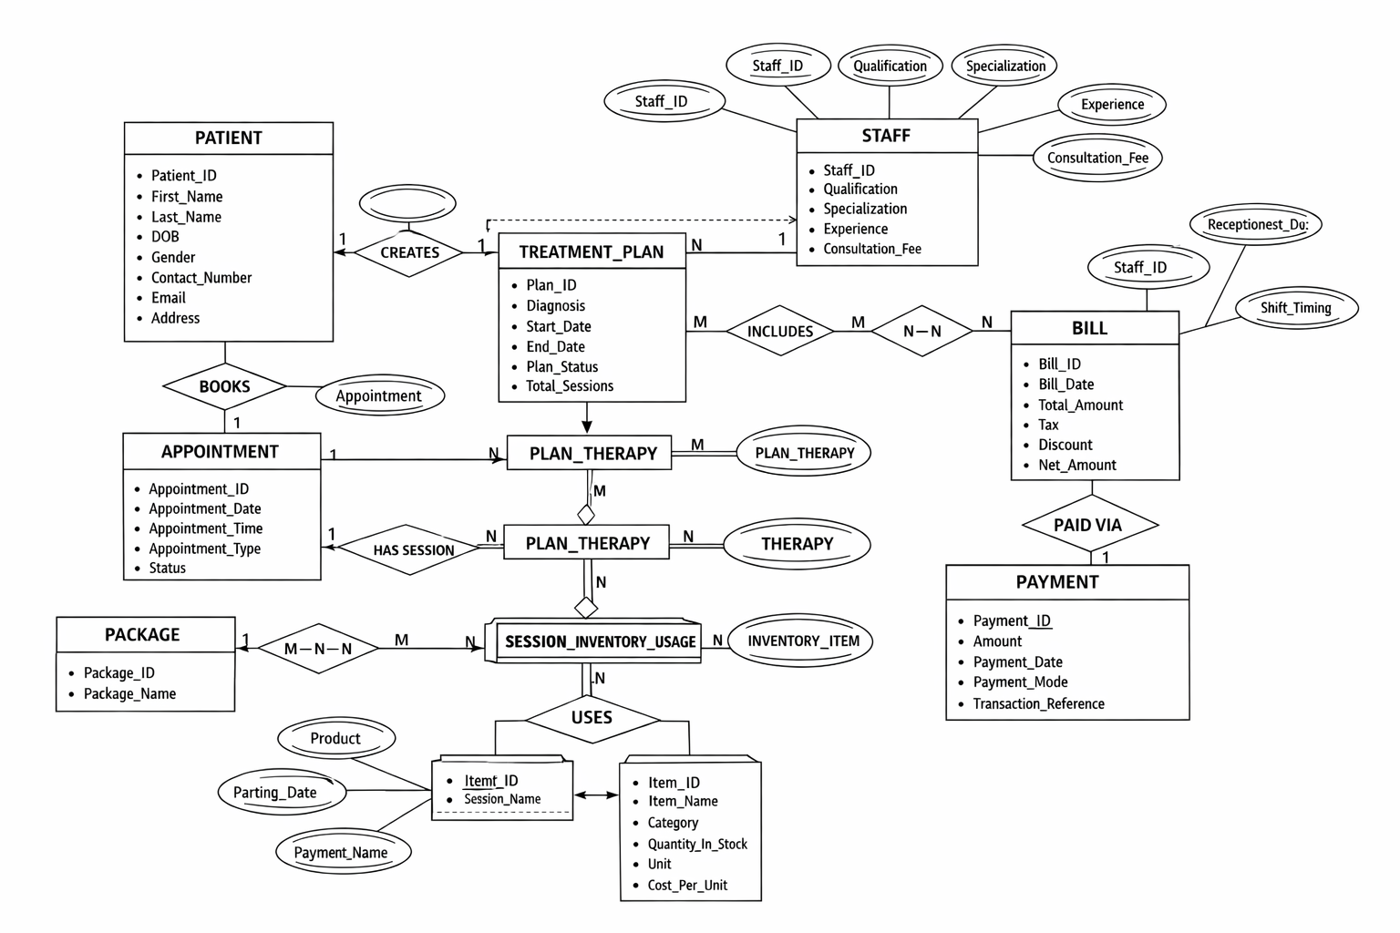
10. NORMALISATION PROCESS
Initially we are assuming the clinic stored everything in ONE large table:
CLINIC_RECORD(
Patient_ID,
Patient_Name,
Contact_Number,
Doctor_Name,
Therapy_List {Therapy1, Therapy2, Therapy3},
Therapy_Duration_List {30, 45, 60},
Session_Dates {01-02-2026, 03-02-2026},
Inventory_Used {OilA, OilB},
Bill_Amount,
Payment_List {5000, 3000}
)

11. Problems:
- Repeating groups (Therapy_List, Session_Dates, Payment_List)
- Multi-valued attributes
- No atomic values
- Massive redundancy
- Update anomalies
- Deletion anomalies
- Insertion anomalies
- This violates 1NF.
- First Normal Form (1NF)
- All attributes must be atomic.
- No repeating groups.
- Each cell must contain single value.

CLINIC_RECORD_1NF(
Patient_ID,
Patient_Name,
Contact_Number,
Doctor_Name,
Therapy_Name,
Therapy_Duration,
Session_Date,
Inventory_Item,
Bill_Amount,
Payment_Amount
)
Functional Dependencies:
- Patient_ID → Patient_Name, Contact_Number
- Therapy_Name → Therapy_Duration
- Bill_ID → Bill_Amount
- (Plan_ID, Therapy_ID) → Frequency
- (Plan_ID, Session_ID) → Session_Date
Yet there are partial and transitive dependencies.
This violates 2NF and 3NF.
- Second Normal Form (2NF)
Must be in 1NF
No partial dependency on composite key
(Plan_ID, Therapy_ID) Are PK
Patient_Name depends only on Patient_ID
Therapy_Duration depends only on Therapy_Name . These are partial dependencies. So we decompose.

PATIENT(
Patient_ID PK,
First_Name,
Contact_Number
)
DOCTOR(
Doctor_ID PK,
Name,
Qualification
)
THERAPY(
Therapy_ID PK,
Therapy_Name,
Duration_Minutes,
Cost
)
TREATMENT_PLAN(
Plan_ID PK,
Patient_ID FK,
Doctor_ID FK
)
PLAN_THERAPY(
Plan_ID PK,
Therapy_ID PK,
Frequency
)
- Third Normal Form (3NF)
- Must be in 2NF
- No transitive dependency
In the bills table-
If:
Net_Amount = Total_Amount + Tax − Discount
Then:
Bill_ID → Total_Amount, Tax, Discount
Total_Amount, Tax, Discount → Net_Amount
That is transitive dependency.
To satisfy strict 3NF:
Either:
- Compute Net_Amount dynamically
OR
- Ensure it is derived but not used as dependency
In proper 3NF:
All non-key attributes depend only on the primary key.
In our final design:
- No attribute depends on non-key attribute.
- All dependencies are direct.
- Thus 3NF satisfied.

BCNF Justification
A relation is in BCNF if:
For every non-trivial functional dependency:
X → Y
X must be a super key.
Check:
- Patient_ID → attributes
- Therapy_ID → attributes
- Plan_ID → attributes
- (Plan_ID, Therapy_ID) → Frequency
All determinants are super keys.
Thus:
The database is in BCNF.
The PrakritiOPD database schema has been normalized up to Third Normal Form (3NF) and satisfies BCNF conditions. All functional dependencies have been analyzed, and partial and transitive dependencies have been eliminated through proper decomposition. This ensures data consistency, reduces redundancy, and improves scalability of the system.
12. Database Implementation – DDL Phase
The logical database design was implemented in MySQL Workbench using structured SQL Data Definition Language (DDL) commands. The database PrakritiOPD was created to store and manage all operational data of the Panchakarma OPD clinic.
A total of 16 normalized tables were created, representing core entities such as Patient, Staff, Doctor, Therapist, Therapy, Package, Treatment Plan, Appointment, Therapy Session, Inventory, Billing, and Payment.
The implementation ensures:
- Entity Integrity through Primary Keys.
- Referential Integrity through Foreign Key constraints.
- Domain Integrity using ENUM types and CHECK constraints.
- Composite Keys for associative and weak entities.
- Specialization/Generalization via Staff supertype and role-based subtypes.
- Resolution of Many-to-Many relationships using associative tables such as PLAN_THERAPY and PACKAGE_THERAPY.
All constraints were carefully defined to maintain consistency, prevent invalid data insertion, and support real-world clinic operations.
The database structure is fully normalized up to Third Normal Form (3NF), ensuring minimal redundancy and efficient data management. Sample data was inserted in a logically structured order to maintain referential integrity and avoid foreign key violations. The data represents realistic operational scenarios of a premium Ayurvedic OPD clinic.
The following entities were populated:
- Staff and role-based specializations (Doctor, Therapist, Receptionist)
- Patient records
- Therapy master data
- Panchakarma packages
- Package–therapy mappings
- Inventory items

13. DML Implementation
The dataset includes more than 30 records across core entities, ensuring meaningful testing of relationships, constraints, and complex queries.
- This structured data population enables.
- Testing of treatment plan workflows
- Session scheduling demonstrations
- Billing and payment simulation
- Inventory tracking verification
- Performance testing for joins and aggregations
The inserted data reflects real-world clinical operations and supports further implementation of triggers, transactions, and analytical queries.

13. Advanced Database Features

Check Constraints
Inventory table includes:
- CHECK (Quantity_In_Stock ≥ 0)
- CHECK (Cost_Per_Unit ≥ 0)
- These prevent invalid data entry.

Trigger Implementation

Trigger Implementation
Triggers are database mechanisms that automatically execute predefined actions when specific events occur on a table. In the PrakritiOPD system, triggers are used to enforce important business rules related to inventory management and billing operations.

1. Inventory Deduction Trigger
A BEFORE INSERT trigger was implemented on the Session_Inventory_Usage table.
Purpose
- Validate stock availability before recording inventory usage.
- Prevent inventory quantity from becoming negative.
- Automatically deduct the used quantity from available inventory.
Trigger Logic
- Fetch the current stock from the Inventory_Item table.
- Compare the current stock with the Quantity_Used.
- If the required quantity exceeds available stock → raise a custom error.
- Otherwise → deduct the used quantity from the inventory stock.
This trigger ensures that therapy sessions cannot consume more inventory than what is available, thereby maintaining accurate stock records and enforcing business rules at the database level.

2. Bill Amount Calculation Trigger
A BEFORE INSERT trigger was implemented on the Bill table.
Purpose
- Automatically calculate the Net Amount of a bill.
- Prevent incorrect billing calculations.
Trigger Logic
- Retrieve the values of Total_Amount, Tax, and Discount.
- Calculate the final bill amount using the formula:
Net_Amount = Total_Amount + Tax − Discount
- Store the computed value in the Net_Amount field before inserting the record.
This trigger ensures consistent and accurate billing calculations by automatically deriving the final payable amount at the database level.
C. Views
were created to simplify complex queries and provide meaningful summarized data to users without exposing underlying table complexity.
The following views were implemented:
1. Patient Treatment Summary View
Displays patient details along with their treatment plans and assigned doctors.
2. Therapist Session Workload View
Shows the number of therapy sessions handled by each therapist.
3. Inventory Status View
Displays current inventory levels and identifies items with low stock.
Views help improve query readability, enhance security by restricting direct table access, and provide quick reporting capabilities for clinic management.

D. Stored Procedures
Stored procedures were implemented to encapsulate frequently used database operations and improve system efficiency.
Two stored procedures were developed:
1. Create Treatment Plan Procedure
This procedure inserts a new treatment plan for a patient and assigns a doctor along with treatment duration.
2. Record Payment Procedure
This procedure records payment made by a patient against a generated bill and updates the payment history.
Stored procedures improve code reusability, reduce redundancy, and enforce consistent data manipulation logic within the database.

14. System Workflow
- Patient registers.
- Doctor creates Treatment Plan.
- Package assigned (optional).
- Therapies mapped to plan.
- Therapy Sessions scheduled.
- Inventory usage recorded.
- Stock deducted automatically.
- Bill generated.
- Payment recorded.
- This workflow simulates real-world OPD clinic operations.

